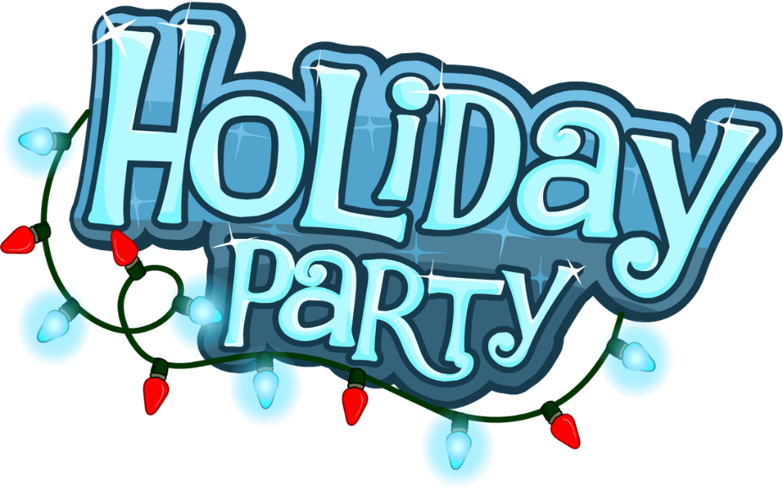
Please join us for our 2018 Holiday Party. This year will feature a bull /oyster roast themed menu. We will have slot machines, casino games and prizes!!!!
Saturday, December 8th 2018
7:00-11:00
Martin’s East
9000 Pulaski Highway
Baltimore, MD 21220

We will be honoring our recent retirees during the cocktail reception beginning at 7:00pm. Please join us to celebrate their accomplishments and plan to arrive right at 7 for a chance to win a day off!!!!!

HoteL Reservations
Hampton Inn Baltimore/White Marsh
8225 Towne Center Drive, Baltimore, MD 21236
410-931-2200
$109.00/night + tax
Please contact Julie Bechtel (443-270-5926) for a reservation link

Transportation will be provided between the hotel and party location from 6:30-11:30

Please RSVP by Monday, November 26, 2018 to Julie Bechtel
443-270-5926, 443-867-4083 or jbechtel@mcleancontracting.com

